PRESS RELEASE

COMMUNICATIONS AND MEDIA TEAM OF THE 2023 ASEAN SUMMIT

No.02/SP/TKM-ASEAN2023/ENG/4/2023

National Police to Deploy 2,627 Personnel to Secure 2023 ASEAN Summit

Jakarta, 28 April 2023 – The National Police will deploy 2,627 personnel to secure the 2023 ASEAN Summit in Labuan Bajo, West Manggarai Regency, East Nusa Tenggara (NTT), on 9—11 May.

National Police's Public Relations Division head Inspector General Sandi Nugroho, in his statement in Jakarta, Friday, 28 April, said the 2,627 personnel will come from the NTT Regional Police, West Nusa Tenggara (NTB) Regional Police, and the National Police Headquarters.

"The plan is 2,627 personnel to be deployed; 947 from the National Police Headquarters, 1,660 from the NTT Regional Police, and 20 from the NTB Regional Police," Sandi said.

He explained that all personnel securing the 2023 ASEAN Summit would be deployed to several locations, such as airports, accommodations for delegates or heads of state attending, and the summit venues.

Before the 2023 ASEAN Summit on 9—11 May, he added, there will be a number of side events outside of the main event on 7—9 May.

Security for the side events will be the full responsibility of the National Police. In the meantime, for the main event, the National Police gave operational control of personnel in rings 1, 2, and 3 under the supervision of the presidential security detail.

"Polri provides BKO (inter-unit personnel) assistance in rings 1, 2, and 3. For side events, it is the full responsibility of the Police," he added.

Some things that have been strengthened in terms of security are facilities in Labuan Bajo by, among others, installing surveillance cameras (CCTV) to enhance control centers spread from the airport, event venues, and hotels.

"Regarding body-worn cameras, we can provide static and mobile CCTV," he explained.

Furthermore, Sandi explained that the CCTV system was equipped with facial recognition technology to detect guest lists or people suspected of committing a crime.

In this safeguard, he added, the National Police coordinated with other relevant stakeholders and accommodation providers to handle obstacles. Sandi stressed that the National Police is ready to protect the security of delegates and heads of state during the 2023 ASEAN Summit.

"The Indonesian National Police is ready to maintain the security and comfort of delegates and heads of state during the ASEAN Summit in Labuan Bajo, NTT," said Sandi Nugroho. (Laily/TR/Elvira)

***

For further information, please contact:
Director General of Public Information and Communications of the Ministry of Communications and Informatics – Usman Kansong (0816785320).

Get more information at http://asean2023.id and https://infopublik.id

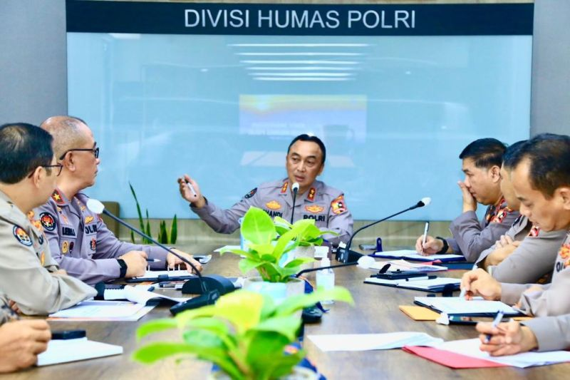

National Police's Public Relations Division head Inspector General Sandi Nugroho briefs his staff members in Jakarta, Friday, 28 April 2023. (ANTARA/HO-Divisi Humas Polri)

